“Alumni Connect”

Project Report submitted for the partial fulfilment of grade for the course

Data Structures and Algorithms -3 (25CS2103E)

in

DEPARTMENT OF COMPUTER SCIENCE ENGINEERING

by

MIRIYALA THARAVARSHINI :2520030052

NANDITHA :2520030013

MUSANI GAYATHRI :2520030175

Team Number: 19
Section: 2

Under the Guidance of

Dr. S. Vinay Kumar
Associate Professor
Department of Computer Science and Engineering





2026-27

DEPARTMENT OF COMPUTER SCIENCE ENGINEERING

Declaration

The Project Report entitled “Alumni Connect” is a record of Bonafide work of MIRIYALA THARAVARSHINI– 2520030052, NANDITHA– 2520030013 MUSNI GAYATHRI – 2520030175 submitted in partial fulfillment for the award of B. Tech in Computer Science and Engineering. The results embodied in this report have not been copied from any other departments/University/Institute.

MIRIYALA THARAVARSHINI– 2520030052
NANDITHA– 2520030013
MUSNI GAYATHRI– 2520030175

DEPARTMENT OF COMPUTER SCIENCE ENGINEERING

CERTIFICATE

This is to certify that the mini project based report entitled “Alumni Connect” is a bonafide work done and submitted by MIRIYALA THARAVARSHINI– 2520030052, NANDITHA– 2520030013, MUSNI GAYATHRI – 2520030175 in partial fulfillment of the requirements for the award of the degree of BACHELOR OF TECHNOLOGY in Department of Computer Science Engineering, during the academic year 2026-27.

Signature of the Guide Signature of the HOD
(Dr. S. Vinay Kumar) (Dr. P. Venkateshwara Rao)

Signature of the External Examiner
ACKNOWLEDGEMENT

We express our sincere gratitude to our guide, Dr. S. Vinay Kumar, Associate Professor, Department of Computer Science and Engineering, for his valuable guidance, constant encouragement and timely suggestions throughout the course of this project. His insights into data structures and algorithms helped us to choose the right approach for every module of Alumni Connect.
We are thankful to Dr. P. Venkateshwara Rao, Associate Professor and Head of the Department of Computer Science and Engineering, for providing the facilities and a supportive environment to carry out this work. We also thank all the faculty members of the department for their help and cooperation.
Finally, we thank our friends and family members for their continuous support and motivation, which helped us to complete this project successfully.

MIRIYALA THARAVARSHINI– 2520030052
NANDITHA– 2520030013
MUSNI GAYATHRI– 2520030175

Abstract
Alumni Connect is a web-based platform designed to strengthen communication and collaboration between students, alumni, and educational institutions. The system provides a centralized platform where alumni can create profiles containing their educational background, professional experience, skills, organizations, and achievements. Students can search and connect with alumni based on their interests, skills, career goals, and organizations. The platform supports mentorship by allowing students to seek career guidance and professional advice from experienced alumni. Alumni can also share job opportunities, internships, events, and useful resources with students.
An integrated messaging feature enables direct communication between students and alumni. The system also provides an administrative module for managing users, profiles, connections, and activities. By bringing students and alumni together in one platform, Alumni Connect promotes networking, knowledge sharing, career development, mentorship, and placement opportunities. It helps institutions maintain organized alumni records while creating a strong and active alumni community. The system applies suitable data structures and algorithms, namely hash maps, a trie, a graph, heaps and queues, so that searching, recommendation and messaging remain efficient as the number of users grows.
Keywords: Alumni network, Mentorship, Hash map, Trie, Graph, Priority queue, Web application.
Table of Contents
 |  |  | Page No.
 | Acknowledgement
 | Abstract
 | Table of Contents
 | List of Figures
1 | Introduction | 1.1 Overview  1.2 Problem Statement  1.3 Scope of the Project  1.4 Objectives  1.5 Organization of the Report | 1–4
2 | System Requirements | 2.1 Existing Systems and Literature Review  2.2 Functional Requirements  2.3 Non-Functional Requirements  2.4 Hardware Requirements  2.5 Software Requirements | 5–8
3 | System Design | 3.1 High-level Architecture Diagram  3.2 Description of Each Layer  3.3 Module Design  3.4 Data Structures and Algorithms Used  3.5 Data Design  3.6 Workflow of Connection Recommendation | 9–14
4 | Implementation | 4.1 Module-wise Implementation  4.2 Front-end Logic (UI Rendering and State Management)  4.3 API Integration  4.4 Persistence and Index Rebuilding | 15–22
5 | Results | 5.1 Output Screens  5.2 Functional Test Cases  5.3 Complexity Analysis  5.4 Discussion | 23–26
6 | Challenges & Limitations | 6.1 Issues Faced during Development  6.2 Solutions Applied  6.3 Limitations of the System | 27–28
7 | Conclusion & Future Work | 7.1 Conclusion  7.2 Future Work  7.3 Skills Learned during Development | 29–30
 | References | Books, tutorials, APIs and documentation sites used | 31
List of Figures
1.1 Overview of the Alumni Connect ecosystem 1
2.1 Use-case diagram of Alumni Connect 7
3.1 High-level architecture of Alumni Connect 9
3.2 Trie used for prefix search and autocomplete 12
3.3 Graph model of student–alumni connections with adjacency list 13
3.4 Flow chart of the connection recommendation process 14
5.1 Login and registration page 23
5.2 Alumni profile page 23
5.3 Alumni search with filters and autocomplete 23
5.4 Connection requests, suggestions and mentorship page 24
5.5 Messaging window between a student and an alumnus 24
5.6 Administrator dashboard 24

1. INTRODUCTION

1.1 Overview
Educational institutions invest years in shaping their students, yet the relationship between an institution and its graduates often weakens soon after convocation. Alumni hold valuable experience in the form of career paths, industry contacts, hiring influence and practical advice that current students rarely get a chance to tap. At the same time, institutions need well-organised alumni records for placements, accreditation, outreach and community building. In most colleges these records are scattered across spreadsheets, social-media groups and personal contacts, which makes networking informal, unreliable and hard to scale.
Alumni Connect is a web-based platform designed to strengthen communication and collaboration between students, alumni and the institution, as shown in Fig. 1.1. Alumni create structured profiles containing their educational background, professional experience, skills, organisations and achievements. Students search for alumni and connect with them based on interests, skills, career goals and organisations, seek mentorship, and exchange messages directly. Alumni can also share job opportunities, internships, events and useful resources, while an administrative module manages users, profiles, connections and activities.
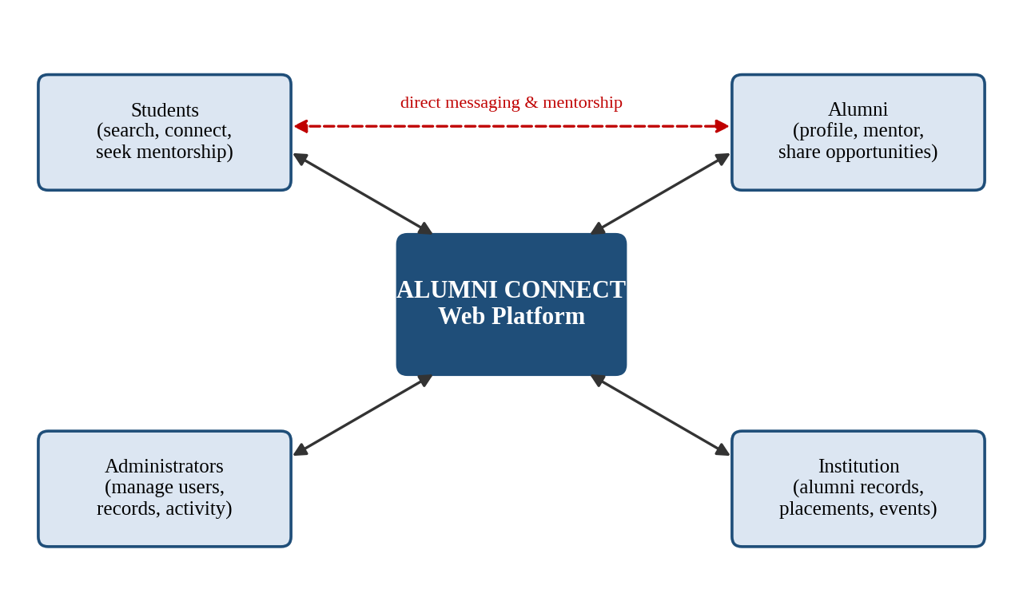
Fig. 1.1 Overview of the Alumni Connect ecosystem
Because this project is carried out for the course Data Structures and Algorithms-3, the emphasis is on how a careful choice of data structures and algorithms keeps such a platform fast and scalable. A data structure is a way to organise and store data that is usually chosen for efficient access to data [1]. Alumni Connect uses hash maps for constant-time look-ups [2], a trie for prefix-based search [5], a graph to model student–alumni connections [4], heaps to rank the best matches [1], and queues to deliver messages in order [3].

1.2 Problem Statement
Students who want career guidance usually do not know which alumni work in their field of interest, and alumni who are willing to help have no convenient channel to reach students. The existing practice suffers from the following drawbacks:
- There is no centralised, searchable database of alumni with up-to-date professional details.
- There is no structured way for students to request mentorship or for alumni to offer it.
- Jobs, internships and events are shared through informal groups and reach only a small audience.
- Communication depends on personal contacts rather than a reliable, institution-managed channel.
- The institution cannot easily maintain organised alumni records or measure alumni engagement.
The problem addressed in this work is to design and develop a web-based platform on which alumni and students can create profiles, search, connect, seek and offer mentorship, share opportunities and communicate, while administrators manage the system. The platform must use appropriate data structures and algorithms so that response time remains low as the number of users and connections grows.
Several challenges are involved: keeping search responsive as profiles accumulate, recommending relevant alumni rather than random ones, protecting the privacy of users and preventing misuse of the messaging feature, and keeping the in-memory indexes consistent with the data stored permanently in the database.

1.3 Scope of the Project
The scope of Alumni Connect covers the following functions:
- Registration, login and role-based access for students, alumni and administrators.
- Creation and maintenance of alumni and student profiles.
- Search and filtering of alumni by name, skill, organisation, batch and career interest.
- Sending, accepting and rejecting connection requests, and mentorship requests.
- Posting and browsing of jobs, internships, events and resources.
- One-to-one messaging between connected users.
- An administrative module for managing users, profiles, connections and activity logs.
The following are outside the scope of the present version: a native mobile application, online payments or donations, audio/video calling, integration with external social networks, and automated recommendation using machine learning.

1.4 Objectives
- To provide one centralised platform that connects students, alumni and the institution.
- To let alumni maintain rich profiles and let students discover them quickly through search and filters.
- To support mentorship by matching students with suitable alumni.
- To enable alumni to share opportunities, events and resources with students.
- To provide secure direct messaging and an administrative module for governance.
- To apply hash maps, tries, graphs, heaps, queues and stacks so that every major operation is efficient.
- To help the institution maintain organised alumni records and build an active alumni community.

1.5 Organization of the Report
The remainder of this report is organised as follows. Chapter 2 presents the existing approaches, the functional and non-functional requirements, and the hardware and software specifications. Chapter 3 describes the system architecture, the modules and the choice of data structures. Chapter 4 explains the implementation of each module using pseudocode. Chapter 5 presents the results, including the output screens, test cases and complexity analysis. Chapter 6 discusses the challenges faced and the limitations of the system. Chapter 7 concludes the report and suggests future work. The references are listed at the end.

2. SYSTEM REQUIREMENTS

2.1 Existing Systems and Literature Review
Networking between students and alumni is currently supported by three broad kinds of solutions. General-purpose professional networking sites offer large user bases but are not tied to any one institution, so a student must filter through a very large number of unrelated profiles and cannot be sure that a person really belongs to the institution. Institutional alumni directories are usually static lists with limited search and little interaction. Informal channels such as messaging groups and shared spreadsheets are easy to start but are unstructured, hard to search and difficult to maintain. Table 2.1 summarises these approaches and the gaps that Alumni Connect aims to fill.
Table 2.1: Comparison of existing approaches
Approach | Strengths | Gaps / limitations
General professional networking sites | Large network, rich features | Not institution-specific; no verification of alumni status; weak mentorship focus
Institutional alumni directories | Official records | Mostly static; limited search; no messaging, mentorship or opportunity sharing
Messaging groups and spreadsheets | Quick and free to set up | Unstructured; hard to search; no access control; records quickly become outdated
Alumni Connect (proposed) | Institution-managed, searchable, mentorship and opportunity features in one place | Needs initial data entry and administrator approval of users

Research on network analysis shows that graph-based measures such as mutual connections and shortest paths describe relationships between people effectively [4], which motivates the use of a graph for connections and recommendations. The trie, introduced by Fredkin [5], is a classical structure for prefix search and autocomplete, and heaps provide efficient retrieval of the best-ranked items [1]. Existing solutions rarely combine these techniques in an institution-focused alumni platform, which is the gap addressed by this project.

2.2 Functional Requirements
The functional requirements describe the functions that the system must perform. They are grouped by module in Table 2.2, and the main interactions of each actor are shown in the use-case diagram of Fig. 2.1.
Table 2.2: Functional requirements
ID | Module | Requirement
FR1 | Authentication | The system shall allow students and alumni to register with a valid e-mail and password and to log in and log out securely.
FR2 | Authentication | The system shall provide role-based access for Student, Alumni and Administrator.
FR3 | Profile | Alumni shall create and edit profiles containing education, experience, skills, organisation and achievements.
FR4 | Profile | Students shall create profiles with branch, year, interests and career goals.
FR5 | Search | Users shall search alumni by name, skill, organisation, batch or career interest, with filters.
FR6 | Search | The system shall provide autocomplete suggestions while a search term is being typed.
FR7 | Connections | Users shall send, accept, reject and withdraw connection requests and view their connections.
FR8 | Connections | The system shall suggest relevant alumni based on mutual connections, skills and organisation.
FR9 | Mentorship | Students shall request mentorship; alumni shall accept or decline and set their availability.
FR10 | Mentorship | The system shall recommend the best-matching mentors for a student.
FR11 | Opportunities | Alumni shall post jobs, internships, events and resources with a deadline.
FR12 | Opportunities | Students shall browse and filter opportunities, which expire automatically after the deadline.
FR13 | Messaging | Connected users shall exchange messages and view conversation history.
FR14 | Notifications | The system shall notify users of requests, acceptances and new messages.
FR15 | Administration | Administrators shall approve, block or delete users and moderate profiles and posts.
FR16 | Administration | The system shall maintain an activity log and allow the last administrative action to be undone.
FR17 | Reports | Administrators shall view statistics on users, connections and opportunities.

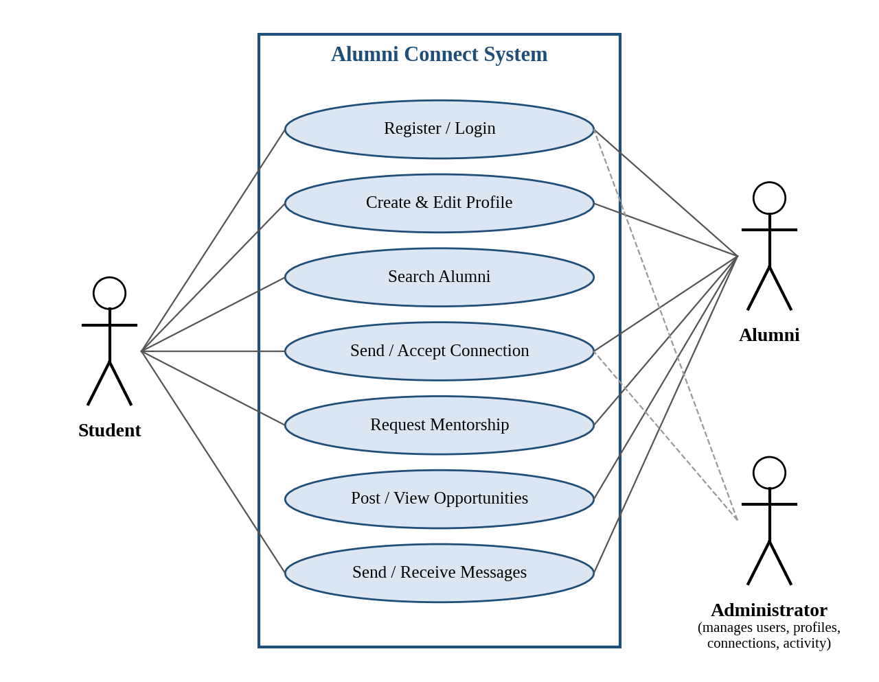
Fig. 2.1 Use-case diagram of Alumni Connect

2.3 Non-Functional Requirements
Non-functional requirements describe the quality attributes of the system, such as response time, usability, scalability and reliability. They are summarised in Table 2.3.
Table 2.3: Non-functional requirements
Attribute | Requirement
Performance / response time | Search results and autocomplete shall be returned within 2 seconds under normal load; ordinary pages shall load within 3 seconds.
Usability | The interface shall be simple and consistent, with clear navigation, form validation and helpful error messages.
Scalability | The design shall support growth in users and connections without redesign; core operations shall run in constant, logarithmic or near-linear time.
Reliability and availability | Data shall be stored permanently so that it is not lost on restart; indexes shall be rebuilt automatically at start-up.
Security | Passwords shall be stored only as salted hashes; all pages shall check the role of the user; inputs shall be validated to prevent injection.
Privacy | Contact details shall be visible only as permitted by the user; messaging shall be limited to connected users.
Maintainability | The code shall be modular, with each module (profile, search, connection, etc.) separately testable.
Portability / compatibility | The application shall work on current versions of Chrome, Edge and Firefox on desktop and mobile screens.

2.4 Hardware Requirements
Table 2.4: Hardware requirements
Component | Development machine | Deployment server
Processor | Intel Core i3 / AMD Ryzen 3 or better | 2 vCPU or better
Memory (RAM) | 4 GB minimum (8 GB recommended) | 4 GB or more
Storage | 500 MB free space | 10 GB or more
Network | Broadband internet connection | Public IP / domain name
Display | 1366 x 768 or higher | Not required

2.5 Software Requirements
Table 2.5: Software requirements
Category | Specification
Operating system | Windows 10/11, Ubuntu 22.04 or macOS
Front end | HTML5, CSS3 and JavaScript (ES6) [11]
Back end | Python 3.10 or later with the Flask web framework [9], [10]
Database | SQLite 3 for development; a relational server database such as MySQL for deployment [12]
Web browser | Google Chrome, Microsoft Edge or Mozilla Firefox (latest versions)
Tools | Visual Studio Code, Git and GitHub, Postman for API testing

These tools were chosen because they are free, widely documented and well suited to a team project of this size.

3. SYSTEM DESIGN

3.1 High-level Architecture Diagram
Alumni Connect follows a layered architecture in which each layer has a clear responsibility and communicates only with the layer next to it [7]. This separation makes the system easier to understand, test and extend. The four layers are the presentation layer, the application (business logic) layer, the data-structure (index) layer and the persistence layer, as shown in Fig. 3.1.
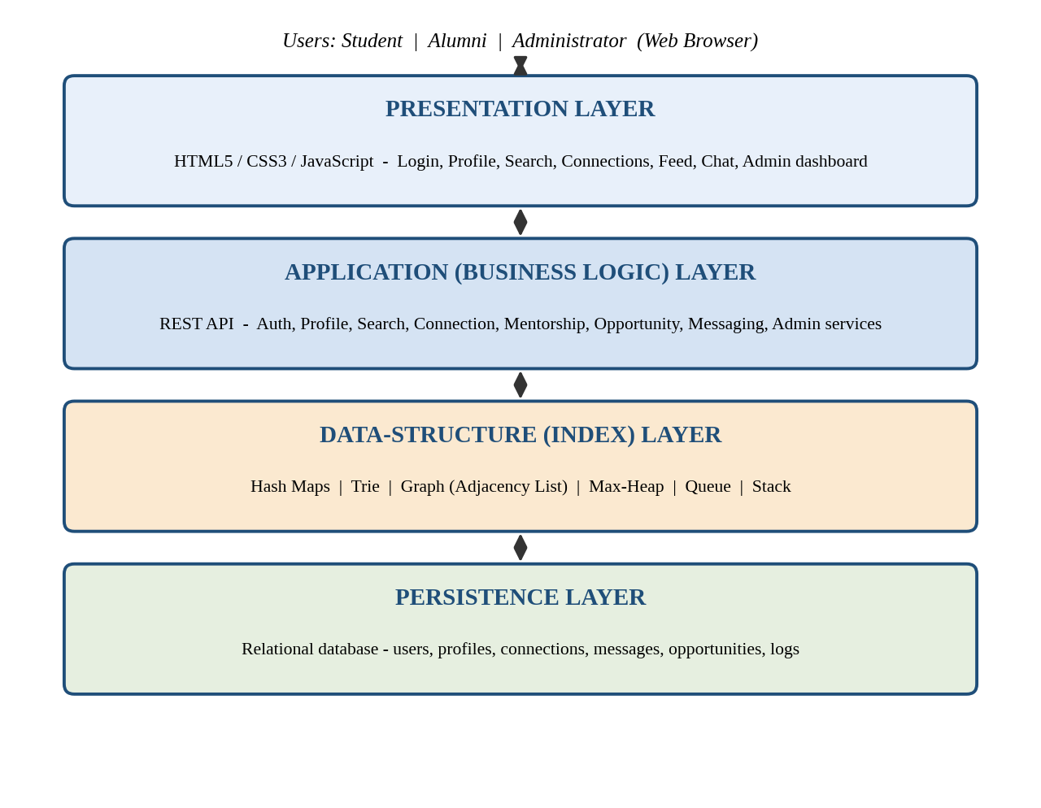
Fig. 3.1 High-level architecture of Alumni Connect

3.2 Description of Each Layer

3.2.1 Presentation layer
The presentation layer is the web interface that runs in the browser. It contains the login and registration pages, profile pages, the search page with autocomplete, the connections and mentorship pages, the opportunity feed, the chat window and the administrator dashboard. It sends requests to the application layer and renders the responses, and it shows only the menus allowed for the role of the logged-in user.

3.2.2 Application (business logic) layer
The application layer exposes a set of REST-style services [8]: authentication, profile, search, connection, mentorship, opportunity, messaging and administration. Each service validates its input, applies the business rules (for example, a user cannot send a request to a person who is already connected) and calls the data-structure layer for fast look-ups and ranking.

3.2.3 Data-structure (index) layer
This layer is the heart of the project. When the application starts, the data stored in the database is loaded into in-memory structures: hash maps for users and profiles, a trie and an inverted index for search, an adjacency-list graph for connections, heaps for ranking and expiry, and queues for conversations. Because these structures live in memory, the most frequent operations avoid repeated database queries and run in the time complexities listed in Chapter 5.

3.2.4 Persistence layer
The persistence layer is a relational database that permanently stores users, profiles, connections, mentorship requests, opportunities, messages and the activity log. Every change made through the application layer is written to the database as well as to the in-memory structures, so that the indexes can be rebuilt after a restart.

3.3 Module Design
The system is divided into six modules. Table 3.1 lists the responsibilities of each module and the main data structures it relies on.
Table 3.1: Modules and their responsibilities
Module | Responsibilities | Main data structures
User and Profile | Registration, login, profile creation and editing, profile visibility | Hash map (by id and by e-mail)
Search | Name, skill and organisation search, filters, autocomplete, ranking of results | Trie, inverted index, max-heap
Connection and Mentorship | Requests, acceptance, suggestions, mentor matching, connection degree | Graph (adjacency list), queue, max-heap
Opportunities | Posting and browsing jobs, internships, events and resources; expiry of old posts | Hash map, type index, min-heap, merge sort
Messaging | Conversations between connected users, inbox ordering, notifications | Queue (FIFO), max-heap
Administration | Approve, block and delete users; moderation; activity log with undo; statistics | Stack, hash map

3.4 Data Structures and Algorithms Used
The choice of data structure for each requirement is justified in Table 3.2. In each case the structure was chosen because it gives the best time complexity for the operation that is performed most often.
Table 3.2: Mapping of requirements to data structures
Requirement | Data structure | Why it is suitable
Find a user by e-mail or id | Hash map | Average O(1) insertion and look-up [2]
Prefix search and autocomplete on names and skills | Trie | Cost depends on the length of the prefix, not on the number of profiles [5]
Filter alumni by skill, organisation or batch | Inverted index (hash map of hash sets) | Direct access to all users with a given attribute; filters combine by set intersection
Represent connections and find mutual friends | Graph as adjacency list | Space proportional to V + E; efficient neighbour traversal [4]
Suggest connections and find connection degree | Breadth-first search (BFS) | Explores the network level by level and finds the shortest path in O(V + E) [1]
Return the top-K best matches | Max-heap (priority queue) | Best item is obtained in O(log n) without sorting all candidates [1]
Deliver messages in order | Queue (FIFO) | Preserves the order of sending
Undo the last admin action | Stack (LIFO) | The most recent action is the first to be reversed
Show opportunities by deadline | Merge sort and min-heap | Stable O(n log n) sort; the earliest deadline is available at the top of the heap [6]

3.4.1 Hash maps and inverted index
A hash map stores key–value pairs and gives average constant-time insertion and look-up [2]. Alumni Connect keeps one map from e-mail to user (used at login) and one from user id to user and to profile. An inverted index maps every skill, organisation and batch to the set of user ids that have it, so a filter such as “skill = Python” returns its result without scanning all profiles.

3.4.2 Trie
A trie is a tree in which every edge is labelled with a character and every path from the root spells a prefix [5]. To search for the prefix “ja”, the system follows the edges j and a and then collects all words that end below that node, as illustrated in Fig. 3.2. The time taken depends only on the length of the prefix and the number of matches, so autocomplete stays fast even when thousands of profiles are stored.
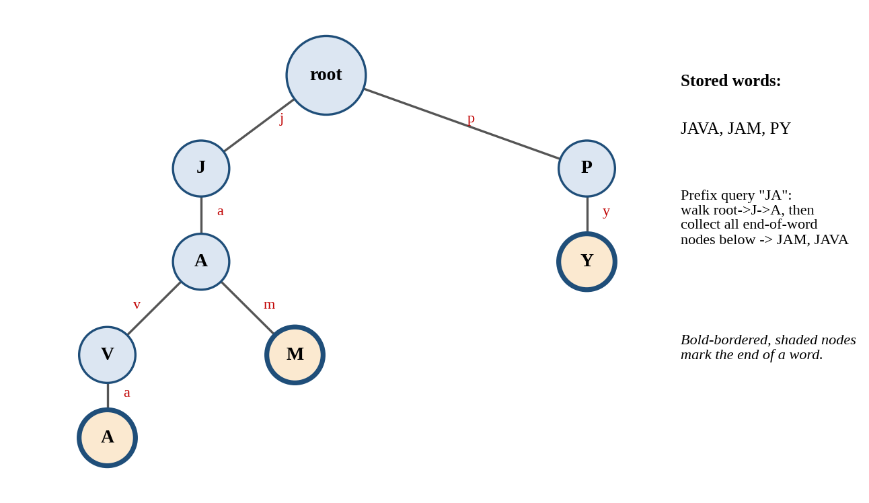
Fig. 3.2 Trie used for prefix search and autocomplete

3.4.3 Graph
Students and alumni are the vertices of an undirected graph, and an accepted connection is an edge between two vertices (Fig. 3.3). The graph is stored as an adjacency list, which needs memory proportional to the number of vertices plus edges and lets the system list the neighbours of a user quickly [3], [4]. Mutual connections, connection degree and recommendations are all computed on this graph.
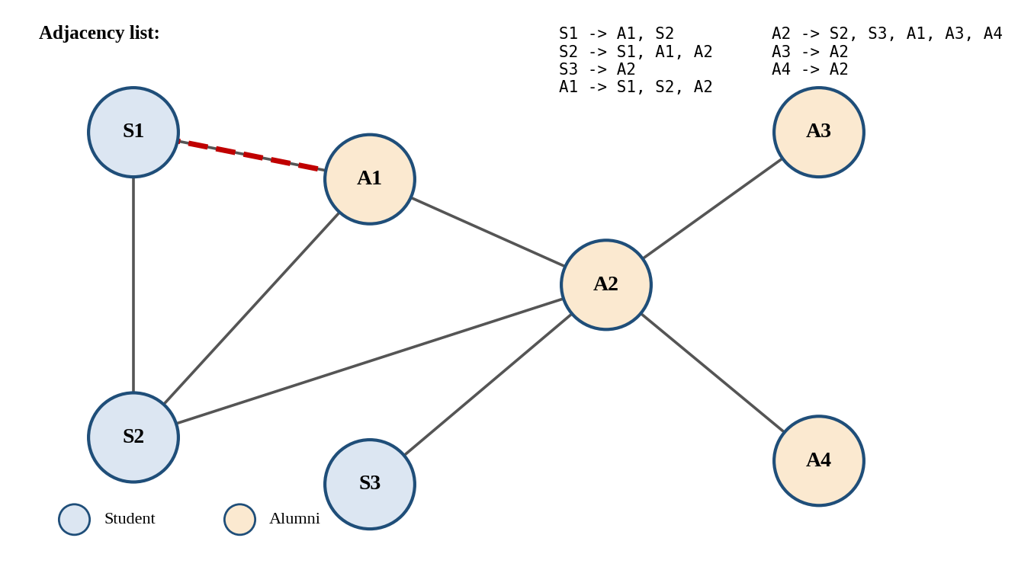
Fig. 3.3 Graph model of student–alumni connections with adjacency list

3.4.4 Heap and sorting
A binary max-heap always keeps the highest-scored item at the top. When a search or recommendation produces n candidate users, the system pushes them into a heap and removes the top K items, which is cheaper than sorting all n items when K is small [1]. For lists that must be fully ordered, such as opportunities by deadline, merge sort is used because it is stable and runs in O(n log n) time [6].

3.4.5 Queue and stack
Every conversation keeps its messages in a first-in-first-out queue so that they are always shown in the order they were sent. The administrator’s activity log is kept as a stack so that the most recent action can be undone first.

3.5 Data Design
The permanent data of the system is organised into the entities listed in Table 3.3.
Table 3.3: Main entities and attributes
Entity | Key attributes
User | user_id, name, e-mail, password_hash, salt, role, status (PENDING / ACTIVE / BLOCKED)
Profile | user_id, headline, education, batch, branch, experience, skills, organisation, achievements, mentorship_available
Connection | user_id_1, user_id_2, status, created_at
MentorshipRequest | request_id, student_id, alumni_id, topic, status, created_at
Opportunity | opp_id, posted_by, type (JOB / INTERNSHIP / EVENT / RESOURCE), title, description, deadline
Message | msg_id, sender_id, receiver_id, text, sent_at, read_flag
ActivityLog | log_id, admin_id, action, target_id, timestamp

3.6 Workflow of Connection Recommendation
The recommendation of alumni to a student is the most algorithmic feature of the system. As shown in Fig. 3.4, the system starts from the adjacency list of the current user, performs a breadth-first search limited to two levels, and counts how many mutual connections each new person has with the user. A score is then calculated from the mutual connections, the overlap of skills and interests, and whether the person belongs to the same organisation or branch. The scored candidates are pushed into a max-heap and the top K are displayed.
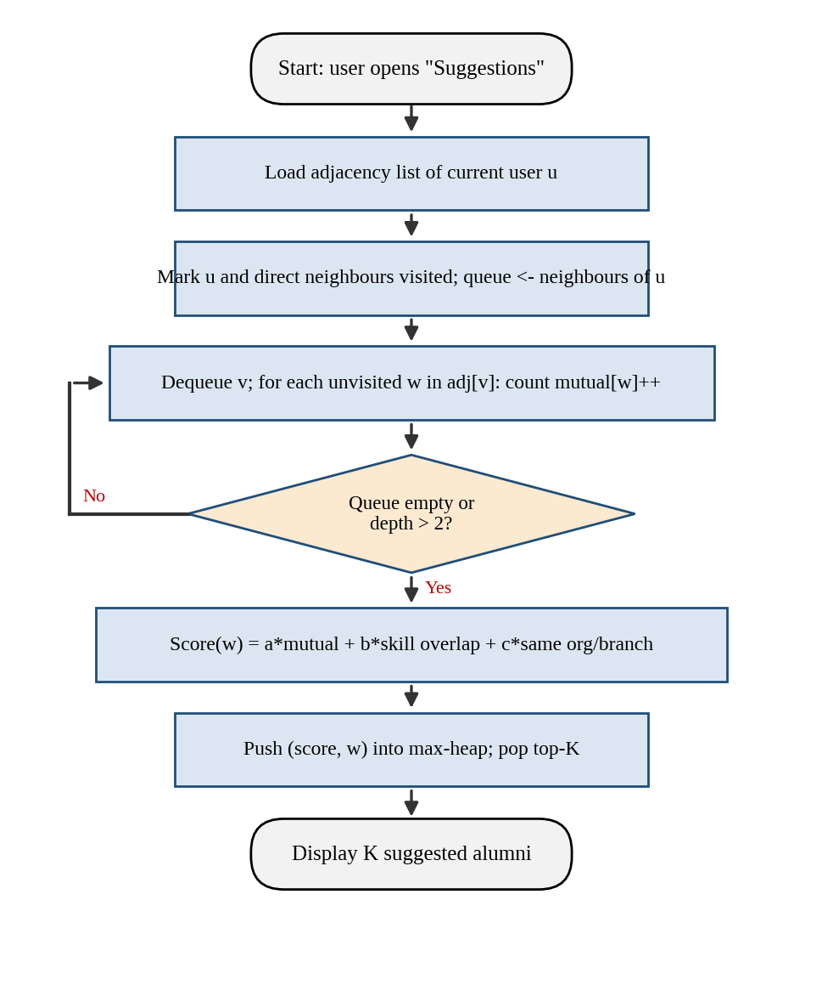
Fig. 3.4 Flow chart of the connection recommendation process
This approach is suitable because it favours people who are close to the user in the network and who share interests, while the heap ensures that only the K best candidates are produced and not the whole candidate list.

4. IMPLEMENTATION

4.1 Module-wise Implementation
This section explains the implementation of each module using pseudocode. The pseudocode is independent of the programming language and uses the following conventions: “<-” denotes assignment, “//” starts a comment, and map.get, map.put and set.add are the usual hash-map and hash-set operations.

4.1.1 User registration and authentication
Registration checks that the e-mail is new, validates the input, stores a salted hash of the password and inserts the user into two hash maps. New users start with the status PENDING until an administrator approves them. Login performs a constant-time look-up by e-mail and compares hashes.
Algorithm 4.1: RegisterUser
ALGORITHM RegisterUser(email, password, name, role)
1 IF usersByEmail.contains(email) THEN
2 RETURN Error("Email already registered")
3 validate(email, password) // format, minimum length
4 salt <- generateSalt()
5 hash <- hashFunction(password + salt)
6 id <- nextUserId()
7 user <- User(id, email, hash, salt, name, role, PENDING)
8 usersByEmail.put(email, user) // O(1) average
9 usersById.put(id, user)
10 persist(user)
11 RETURN id

Algorithm 4.2: Login
ALGORITHM Login(email, password)
1 user <- usersByEmail.get(email)
2 IF user = NULL OR user.status = BLOCKED THEN
3 RETURN Error("Invalid credentials")
4 IF hashFunction(password + user.salt) != user.hash THEN
5 RETURN Error("Invalid credentials")
6 token <- createSession(user.id)
7 sessions.put(token, user.id)
8 RETURN token

4.1.2 Profile management and index building
Whenever a profile is created or edited, the old index entries are removed and the new values are inserted into the trie and the inverted indexes, so that search always reflects the latest data.
Algorithm 4.3: SaveProfile
ALGORITHM SaveProfile(userId, profile)
1 old <- profilesById.get(userId)
2 IF old != NULL THEN removeFromIndexes(userId, old)
3 profilesById.put(userId, profile)
4 trieName.insert(lowercase(profile.name), userId)
5 FOR EACH skill IN profile.skills DO
6 s <- normalize(skill)
7 trieSkill.insert(s, userId)
8 skillIndex[s].add(userId) // inverted index
9 orgIndex[normalize(profile.org)].add(userId)
10 batchIndex[profile.batch].add(userId)
11 persist(profile)

4.1.3 Search and ranking
The trie supports insertion and prefix search. The search algorithm first collects candidates from the name and skill tries, then applies the filters by intersecting the candidate set with the sets from the inverted indexes, and finally ranks the candidates with a max-heap. The relevance score gives the highest weight to an exact name match, followed by skill match, organisation match and batch match.
Algorithm 4.4: Trie insertion and prefix search
ALGORITHM Trie.insert(word, id)
1 node <- root
2 FOR EACH ch IN word DO
3 IF ch NOT IN node.children THEN
4 node.children[ch] <- new TrieNode()
5 node <- node.children[ch]
6 node.isEnd <- TRUE
7 node.ids.add(id)

ALGORITHM Trie.prefixSearch(prefix)
1 node <- root
2 FOR EACH ch IN prefix DO
3 IF ch NOT IN node.children THEN RETURN {}
4 node <- node.children[ch]
5 RETURN collectAll(node) // DFS over the subtree

Algorithm 4.5: SearchAlumni
ALGORITHM SearchAlumni(query, filters, K)
INPUT : query text, filters (skill, org, batch), K
OUTPUT: top-K alumni ranked by relevance
1 q <- lowercase(query)
2 cand <- trieName.prefixSearch(q) UNION
trieSkill.prefixSearch(q)
3 FOR EACH f IN filters DO
4 cand <- cand INTERSECT index[f.type].get(f.value)
5 heap <- new MaxHeap()
6 FOR EACH id IN cand DO
7 heap.push(relevance(id, q, filters), id)
8 result <- []
9 WHILE NOT heap.isEmpty() AND size(result) < K DO
10 result.append(heap.pop())
11 RETURN result

4.1.4 Connection management
A connection request is first stored as pending. Only when the receiver accepts it is an undirected edge added to the graph, by inserting each user into the other’s adjacency list. Both operations take constant time on average.
Algorithm 4.6: SendRequest and AcceptRequest
ALGORITHM SendRequest(fromId, toId)
1 IF fromId = toId OR graph.hasEdge(fromId, toId) THEN
2 RETURN Error("Invalid request")
3 IF pending.contains((fromId, toId)) THEN
4 RETURN Error("Already requested")
5 pending.add((fromId, toId))
6 notify(toId, "New connection request")

ALGORITHM AcceptRequest(fromId, toId)
1 IF (fromId, toId) NOT IN pending THEN RETURN Error
2 pending.remove((fromId, toId))
3 graph.adj[fromId].add(toId)
4 graph.adj[toId].add(fromId)
5 persist(edge(fromId, toId))
6 notify(fromId, "Request accepted")

4.1.5 Recommendations, connection degree and mentor matching
Connection suggestions are generated by the two-level search described in Section 3.6. The connection degree between two users, that is, how many steps separate them in the network, is found by breadth-first search. Mentor matching scores each alumnus who is open to mentorship by the overlap between the student’s interests and the alumnus’s skills (using the Jaccard similarity), the match of career goal with industry, and the match of branch.
Algorithm 4.7: SuggestConnections
ALGORITHM SuggestConnections(u, K)
1 visited <- {u} UNION graph.adj[u]
2 mutual <- new HashMap()
3 FOR EACH v IN graph.adj[u] DO // level 1
4 FOR EACH w IN graph.adj[v] DO // level 2
5 IF w NOT IN visited THEN
6 mutual[w] <- mutual.getOrDefault(w, 0) + 1
7 heap <- new MaxHeap()
8 FOR EACH (w, m) IN mutual DO
9 score <- a*m + b*skillOverlap(u, w)
10 + c*sameOrgOrBranch(u, w)
11 heap.push(score, w)
12 RETURN top K items of heap

Algorithm 4.8: ConnectionDegree (BFS)
ALGORITHM ConnectionDegree(src, dst)
1 IF src = dst THEN RETURN 0
2 queue <- [src]; dist[src] <- 0
3 WHILE queue is not empty DO
4 v <- queue.dequeue()
5 FOR EACH w IN graph.adj[v] DO
6 IF w NOT IN dist THEN
7 dist[w] <- dist[v] + 1
8 IF w = dst THEN RETURN dist[w]
9 queue.enqueue(w)
10 RETURN -1 // not connected

Algorithm 4.9: FindMentors
ALGORITHM FindMentors(student, K)
1 heap <- new MaxHeap()
2 FOR EACH a IN alumniOpenToMentoring DO
3 s <- 0.5 * jaccard(student.interests, a.skills)
4 + 0.3 * match(student.goal, a.industry)
5 + 0.2 * match(student.branch, a.branch)
6 heap.push(s, a)
7 RETURN top K items of heap

4.1.6 Opportunities
Each opportunity is stored in a hash map by id and indexed by type. A min-heap keyed by deadline lets the system discard expired opportunities from the top in O(log n) per item. The feed shown to students is filtered by type and deadline and ordered with merge sort.
Algorithm 4.10: PostOpportunity and GetFeed
ALGORITHM PostOpportunity(alumniId, opp)
1 opp.id <- nextOppId(); opp.postedBy <- alumniId
2 oppById.put(opp.id, opp)
3 typeIndex[opp.type].add(opp.id)
4 deadlineHeap.push(opp.deadline, opp.id) // min-heap
5 persist(opp)

ALGORITHM GetFeed(type, today, K)
1 list <- []
2 FOR EACH id IN typeIndex[type] DO
3 o <- oppById.get(id)
4 IF o.deadline >= today THEN list.append(o)
5 mergeSort(list, BY deadline ASCENDING)
6 RETURN first K items of list

ALGORITHM ExpireSweep(today)
1 WHILE NOT deadlineHeap.isEmpty()
AND deadlineHeap.peek().deadline < today DO
2 deadlineHeap.pop()
3 markExpired(id)

4.1.7 Messaging
Messages are allowed only between connected users, which protects students and alumni from unsolicited messages. Each conversation is identified by the ordered pair of user ids and has a first-in-first-out queue. The inbox is ordered by the time of the last message using a max-heap.
Algorithm 4.11: SendMessage and GetInbox
ALGORITHM SendMessage(from, to, text)
1 IF NOT graph.hasEdge(from, to) THEN
2 RETURN Error("Users are not connected")
3 key <- conversationKey(min(from, to), max(from, to))
4 msg <- Message(nextMsgId(), from, to, text, now())
5 conversations[key].enqueue(msg) // FIFO
6 lastActive[key] <- msg.time
7 persist(msg); notify(to, "New message")

ALGORITHM GetInbox(userId, K)
1 heap <- new MaxHeap() // key = last message time
2 FOR EACH key IN conversationsOf[userId] DO
3 heap.push(lastActive[key], key)
4 RETURN top K conversations

4.1.8 Administration
Administrative actions are allowed only for users whose role is ADMIN. Every action is pushed on a stack so that the last action can be undone. Blocking a user also removes the user from the graph and from every index, so that the user no longer appears in searches or suggestions.
Algorithm 4.12: Administrative actions
ALGORITHM ApproveUser(adminId, userId)
1 IF usersById.get(adminId).role != ADMIN THEN
RETURN Error("Not authorised")
2 u <- usersById.get(userId); u.status <- ACTIVE
3 auditLog.push(Action("APPROVE", adminId, userId, now()))
4 persist(u)

ALGORITHM BlockUser(adminId, userId)
1 (role check as above)
2 usersById.get(userId).status <- BLOCKED
3 FOR EACH v IN graph.adj[userId] DO
4 graph.adj[v].remove(userId)
5 graph.adj.remove(userId)
6 removeFromIndexes(userId, profilesById.get(userId))
7 auditLog.push(Action("BLOCK", adminId, userId, now()))

ALGORITHM UndoLastAction()
1 IF auditLog.isEmpty() THEN RETURN
2 a <- auditLog.pop()
3 reverse(a) // e.g. BLOCK -> ACTIVE

4.2 Front-end Logic (UI Rendering and State Management)
The front end is built with HTML5, CSS3 and JavaScript. Every page has a fixed layout with a navigation bar whose menu items depend on the role of the user. The pages are rendered from data returned by the application layer in JSON format. After each request, the JavaScript code updates only the part of the page that has changed, such as the list of search results or the chat window, instead of reloading the whole page.
The state of the interface is kept in a small JavaScript object that stores the logged-in user and role, the current search query and filters, the list of results, the list of notifications and the open conversation. Whenever the state changes, the corresponding view is drawn again. To avoid sending a request for every key press, the autocomplete box uses a short delay (debouncing) before calling the search service. Forms are validated in the browser before submission and again on the server.

4.3 API Integration
The front end communicates with the application layer through the REST-style endpoints given in Table 4.1. All endpoints other than registration and login require a valid session token, and the role of the user is checked before the operation is carried out.
Table 4.1: Main API endpoints
Method | Endpoint | Purpose
POST | /api/register | Register a new student or alumnus
POST | /api/login | Authenticate and create a session
GET / PUT | /api/profile/{id} | View or update a profile
GET | /api/search?q=&skill=&org=&batch= | Search and filter alumni
GET | /api/autocomplete?prefix= | Suggest names and skills for a prefix
POST | /api/connections/request | Send a connection request
POST | /api/connections/{id}/accept | Accept a connection request
GET | /api/suggestions | Get recommended connections
GET | /api/mentors | Get best-matching mentors
GET / POST | /api/opportunities | Browse or post opportunities
GET / POST | /api/messages/{userId} | Read or send messages
POST | /api/admin/approve, /block, /undo | Administrative actions

4.4 Persistence and Index Rebuilding
Because the indexes are held in memory, they must be rebuilt whenever the server starts. The start-up routine reads each table from the database once and fills the hash maps, the tries, the inverted indexes, the graph and the heaps. After that, every change is applied to both the database and the in-memory structures.
Algorithm 4.13: BuildIndexes (start-up)
ALGORITHM BuildIndexes()
1 FOR EACH row IN database.users DO
2 usersById.put(row.id, row)
3 usersByEmail.put(row.email, row)
4 FOR EACH row IN database.profiles DO
5 SaveProfileInMemory(row) // fills tries and indexes
6 FOR EACH row IN database.connections DO
7 graph.adj[row.u1].add(row.u2)
8 graph.adj[row.u2].add(row.u1)
9 FOR EACH row IN database.opportunities DO
10 oppById.put(row.id, row)
11 deadlineHeap.push(row.deadline, row.id)
12 FOR EACH row IN database.messages ORDER BY sent_at DO
13 conversations[key(row)].enqueue(row)

The start-up cost is linear in the amount of stored data, and it is paid only once per server start.

5. RESULTS

5.1 Output Screens
This section presents the main screens of the Alumni Connect web application. Each figure is numbered as ChapterNo.FigureNo and carries a caption, as required by the guidelines.
[Insert screenshot: Login / registration page]
Fig. 5.1 Login and registration page
[Insert screenshot: Alumni profile page with education, experience and skills]
Fig. 5.2 Alumni profile page
[Insert screenshot: Search page showing autocomplete and filtered results]
Fig. 5.3 Alumni search with filters and autocomplete
[Insert screenshot: Connections / mentorship page]
Fig. 5.4 Connection requests, suggestions and mentorship page
[Insert screenshot: Chat window]
Fig. 5.5 Messaging window between a student and an alumnus
[Insert screenshot: Administrator dashboard with user management and statistics]
Fig. 5.6 Administrator dashboard
The screens show that a student can search alumni quickly, send requests and messages, and that an administrator can manage users from one dashboard.

5.2 Functional Test Cases
The main functions were checked using the test cases of Table 5.1. For each test case the table gives the input and the behaviour expected from the system.
Table 5.1: Functional test cases and expected results
ID | Test scenario | Input | Expected result
T1 | Register with a new e-mail | Valid name, e-mail, password | Account created with status PENDING
T2 | Register with an existing e-mail | E-mail already stored | Error: “Email already registered”
T3 | Login with a wrong password | Valid e-mail, wrong password | Error: “Invalid credentials”
T4 | Search by skill prefix | “pyth” | Alumni whose skills start with “pyth” are listed
T5 | Search with filters | Skill = Java, batch = 2020 | Only alumni satisfying both filters are shown
T6 | Send a duplicate connection request | Request to a user already requested | Error: “Already requested”
T7 | Accept a connection request | Pending request | Edge added; both users appear in each other’s connections
T8 | Message a non-connected user | Receiver not in the sender’s connections | Error: “Users are not connected”
T9 | View expired opportunity | Opportunity with a past deadline | Not shown in the feed
T10 | Block a user as administrator | Valid user id | User removed from searches, connections and suggestions
T11 | Access an admin page as a student | Student session | Access denied

5.3 Complexity Analysis
Table 5.2 gives the time complexity of the main operations. Here m is the length of the string, n is the number of candidates, K is the number of results required, V and E are the numbers of vertices and edges in the connection graph, M is the number of candidate suggestions, and c is the number of conversations of a user.
Table 5.2: Time complexity of the main operations
Operation | Data structure | Time complexity
Login / look-up by e-mail or id | Hash map | O(1) average
Insert a name or skill | Trie | O(m)
Prefix search / autocomplete | Trie | O(m + number of nodes below the prefix)
Apply a filter | Inverted index (hash set) | O(1) look-up; O(min(|A|, |B|)) per intersection
Top-K ranking of n candidates | Max-heap | O(n + K log n)
Send / accept a connection request | Hash set, adjacency list | O(1) average
Connection suggestions | BFS (two levels) + heap | O(sum of degrees of neighbours + M + K log M)
Connection degree | BFS | O(V + E)
Opportunity feed | Merge sort | O(n log n)
Send a message | Queue | O(1)
Inbox ordering | Max-heap | O(c + K log c)
Admin action / undo | Stack | O(1)

5.4 Discussion
The analysis shows that the operations used most often, namely login, request handling, message sending and filter look-up, run in constant time, while search and ranking depend only on the length of the query and the number of candidates and not on the total number of users. Compared with scanning a list of all profiles, which would cost O(N) for every search, the trie and inverted index give the system the ability to remain responsive as the alumni database grows. The use of a heap for ranking avoids sorting all candidates when only the top few are needed, and the graph-based suggestions bring forward people who are close to the student in the network and share interests.

6. CHALLENGES & LIMITATIONS

6.1 Issues Faced during Development
- Slow search: a simple scan over all profiles for each key press made autocomplete slow as the number of profiles increased.
- Inconsistent indexes: after a profile was edited, old skills remained in the indexes, so users appeared in wrong search results.
- Irrelevant suggestions: ordering suggestions only by the number of mutual connections gave results that did not match the interests of the student.
- Duplicate and invalid requests: users could send repeated requests or request themselves.
- Privacy and misuse: open messaging could allow unwanted messages to students and alumni.
- Expired data: old job and event posts continued to appear in the feed.

6.2 Solutions Applied
- A trie and inverted indexes replaced the list scan, so that search time no longer depends on the total number of profiles.
- A removeFromIndexes step was added before every profile update, so that old entries are deleted before the new ones are inserted.
- A combined score of mutual connections, skill overlap and organisation or branch match, ranked with a max-heap, was used for suggestions.
- Checks for self-requests, existing edges and pending requests were added to the connection service.
- Messaging was restricted to connected users, and administrators can block users and review activity.
- A min-heap on deadlines and a deadline check in the feed hide expired posts automatically.

6.3 Limitations of the System
- The indexes are held in the memory of a single server, so very large deployments would need a distributed index or a search engine.
- Alumni status depends on administrator approval; there is no automatic verification against the official records of the institution.
- The scoring weights of the suggestion and mentor-matching algorithms are fixed and are not learned from user behaviour.
- Messaging is text only and has no real-time push notifications, audio or video.
- The platform is a responsive web application; there is no native mobile application.

7. CONCLUSION & FUTURE WORK

7.1 Conclusion
This project designed and developed Alumni Connect, a web-based platform that brings students, alumni and the institution together. It provides alumni profiles, search with filters and autocomplete, connection and mentorship management, sharing of opportunities, direct messaging and an administrative module. By supporting networking, knowledge sharing, career development, mentorship and placement opportunities, the platform helps the institution maintain organised alumni records and build a strong and active alumni community.
From the point of view of the course, the project shows how the right data structures make a real application efficient: hash maps for constant-time look-ups, a trie for prefix search, a graph for connections and recommendations, heaps for ranking, and queues and stacks for messaging and administration. The main limitations are the single-server in-memory indexes and the fixed scoring weights.

7.2 Future Work
- A mobile application with push notifications and real-time chat.
- Automatic verification of alumni using the official records of the institution.
- Learning the scoring weights for suggestions and mentor matching from user feedback using machine learning.
- Video-based mentoring sessions and scheduling of appointments.
- Alumni events management, fund-raising and donation features.
- Analytics dashboards on alumni engagement, placements and mentoring outcomes.
- A distributed search index for very large alumni communities.

7.3 Skills Learned during Development
- Choosing and applying suitable data structures and algorithms to a real problem and analysing their complexity.
- Writing clear pseudocode and converting it into working code.
- Designing a layered architecture and REST-style services.
- Front-end development with HTML, CSS and JavaScript, including state management.
- Database design, version control with Git, testing and teamwork.
- Technical report writing and presentation.

REFERENCES
- T. H. Cormen, C. E. Leiserson, R. L. Rivest and C. Stein, Introduction to Algorithms, 3rd ed. Cambridge, MA, USA: MIT Press, 2009.
- M. A. Weiss, Data Structures and Algorithm Analysis in C++, 4th ed. Upper Saddle River, NJ, USA: Pearson, 2013.
- R. Sedgewick and K. Wayne, Algorithms, 4th ed. Upper Saddle River, NJ, USA: Addison-Wesley, 2011.
- M. E. J. Newman, Networks: An Introduction. Oxford, U.K.: Oxford University Press, 2010.
- E. Fredkin, “Trie memory,” Communications of the ACM, vol. 3, no. 9, pp. 490–499, 1960.
- D. E. Knuth, The Art of Computer Programming, Vol. 3: Sorting and Searching, 2nd ed. Reading, MA, USA: Addison-Wesley, 1998.
- I. Sommerville, Software Engineering, 10th ed. Harlow, U.K.: Pearson, 2016.
- R. T. Fielding, “Architectural styles and the design of network-based software architectures,” Ph.D. dissertation, Univ. of California, Irvine, CA, USA, 2000.
- Python Software Foundation, “Python 3 documentation.” [Online]. Available: https://docs.python.org/3/
- Pallets Projects, “Flask documentation.” [Online]. Available: https://flask.palletsprojects.com/
- MDN Web Docs, “Web technology for developers.” [Online]. Available: https://developer.mozilla.org/
- SQLite Consortium, “SQLite documentation.” [Online]. Available: https://www.sqlite.org/docs.html

